1. **VL with Quadratic: data length, regression error, non-selt match threshold, k, alpha, anomalies, time**

(0-6875), 8, 0.1, 1,2.5, (2425-2590)(78-256), 00:00:13

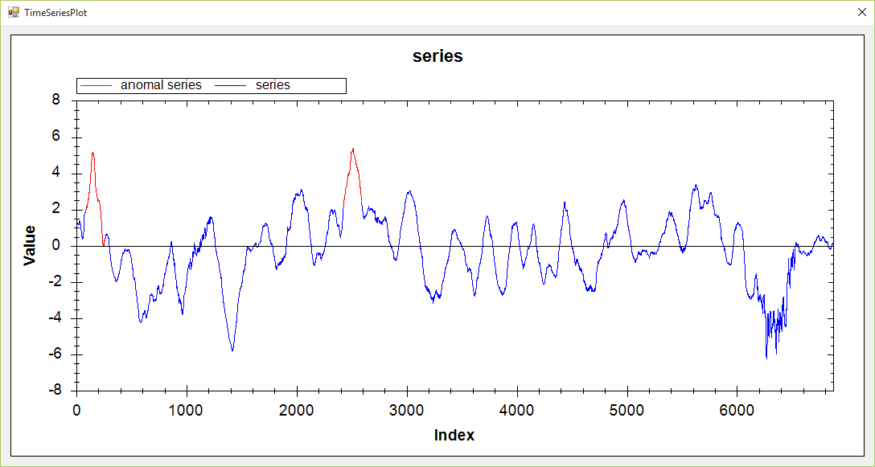

(0-6875), 8, 0.1, 1,2.6, (2425-2590)(78-256), 00:00:14

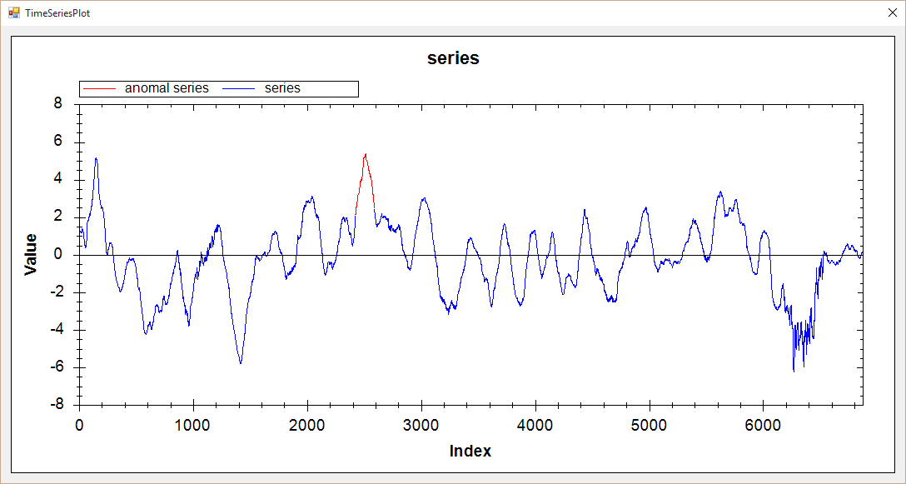

1. **VL with Extrem point: data length, ration, min length, k, alpha, anomalies, time**

(0-6875), 1.05, 20, 1, 3.0,(6178-6737)(2399-2614),00:01:28

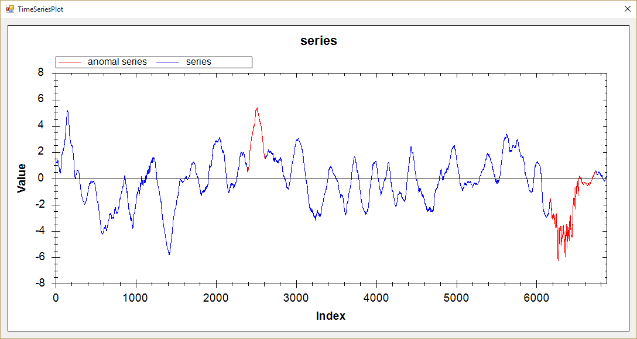(0-6875), 1.05, 10, 1, 2.5,(2399-2614)(6271-6433),00:01:38

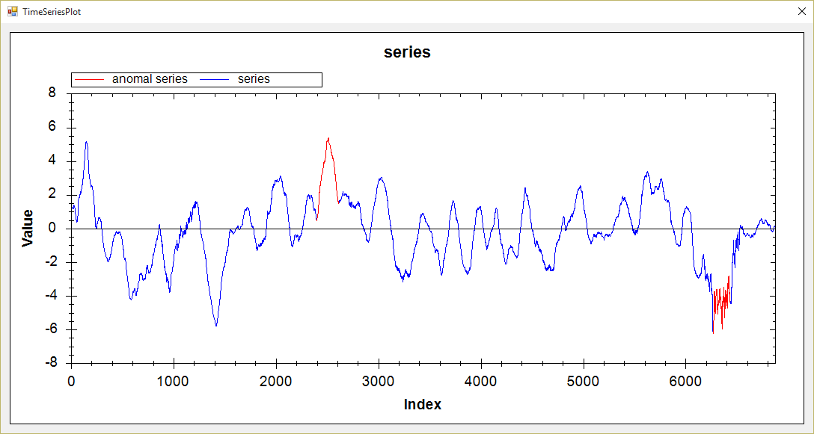

1. **Hot Sax: data length, anomaly length, paa length, discord begin, time**

(0-6875), 200, 20, 2421, 00:01:19

